**Riyadh Tour Guide Application**

**Requirement Gathering**

(RTGD)

**Contents :**

1.0. Introduction 3

2.0. System Requirements 3

RQ01 Museums Guide 3

RQ02 Mosques Guide 4

RQ03 Malls Guide 5

RQ04 Parks Guide 6

# 1.0. Introduction

Riyadh tour guide , is an android mobile application that has 4 categories museums,mosques, malls and parks , tourists and residents of Riyadh city can easily find their place of interest in the application with the ability to navigate to the chosen place through google maps when clicking the place list item.

# 2.0. System Requirements

## RQ01 Museums Guide

Description :

* The system should list the available museums.
* The system should show the name of each museum.
* The system should show a picture of each museum.
* The system should show the working hours of each museum.

|  |  |  |  |  |
| --- | --- | --- | --- | --- |
| **SR No** | **UI Control** | **Control Type** | **Expected Results** | **Data Type** |
| UI! | List Item | List View | Display information of each museum  And open location in google maps  When clicked | List |
| UI2 | Image | Image View | Display Correct Image of Museum | Image |
| UI3 | Museum Name | Text View | Display The Correct Name of the Museum | Text |
| UI4 | Working Hours | Text View | Display The Correct working Hours of the Museum | Text |

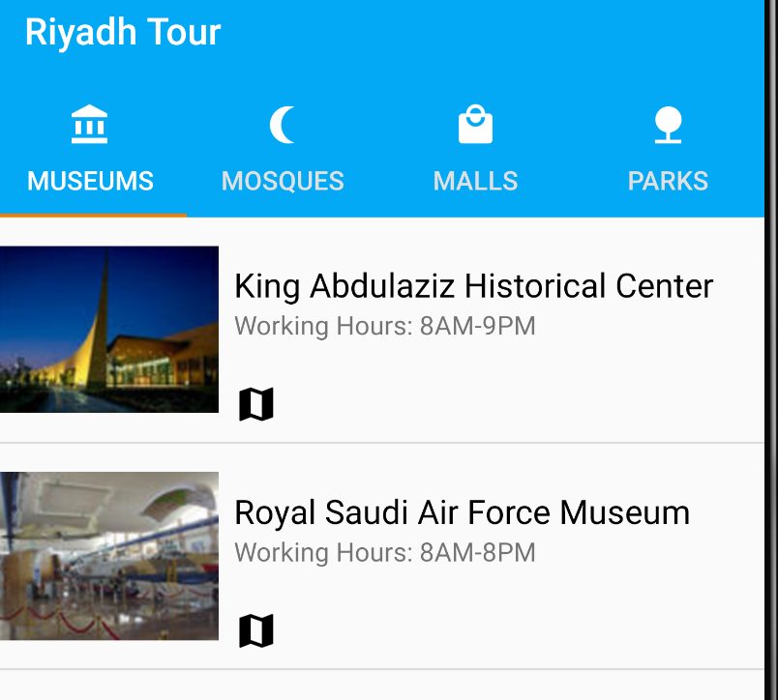

## RQ02 Mosques Guide

Description :

* The system should list the available mosque.
* The system should show the name of each mosque.
* The system should show the working hours of each mosque.

|  |  |  |  |  |
| --- | --- | --- | --- | --- |
| **SR No** | **UI Control** | **Control Type** | **Expected Results** | **Data Type** |
| UI! | List Item | List View | Display information of each mosque and open location in google maps  When clicked | List |
| UI2 | Mosque Name | Text View | Display The Correct Name of the mosque | Text |
| UI3 | Working Hours | Text View | Display The Correct working Hours of the mosque | Text |

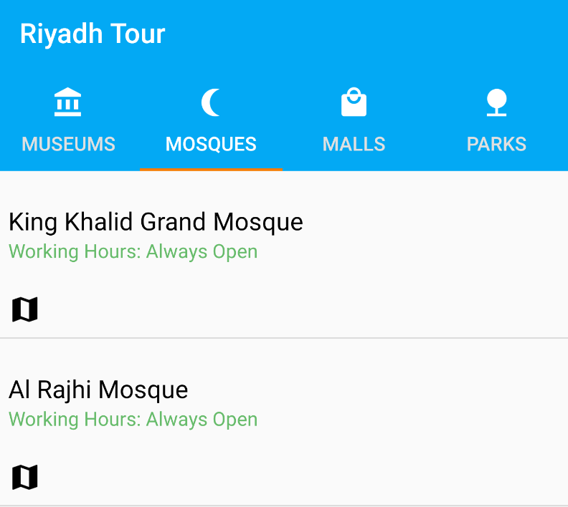

## 

## 

## RQ03 Malls Guide

Description :

* The system should list the available malls.
* The system should show the name of each mall.
* The system should show a picture of each mall.
* The system should show the working hours of each mall.

|  |  |  |  |  |
| --- | --- | --- | --- | --- |
| **SR No** | **UI Control** | **Control Type** | **Expected Results** | **Data Type** |
| UI! | List Item | List View | Display information of each mall  and open location in google maps  When clicked | List |
| UI2 | Image | Image View | Display Correct Image of mall | Image |
| UI3 | Mall Name | Text View | Display The Correct Name of the mall | Text |
| UI4 | Working Hours | Text View | Display The Correct working Hours of the mall | Text |

# 

# 

## RQ04 Parks Guide

Description :

* The system should list the available parks.
* The system should show the name of each park.
* The system should show the working hours of each park.

|  |  |  |  |  |
| --- | --- | --- | --- | --- |
| **SR No** | **UI Control** | **Control Type** | **Expected Results** | **Data Type** |
| UI! | List Item | List View | Display information of each park and open location in google maps  When clicked | List |
| UI2 | Park Name | Text View | Display The Correct Name of the park | Text |
| UI3 | Working Hours | Text View | Display The Correct working Hours of the park | Text |

